**Arab Academy for Science and Technology**

**College of Language and Communication**



**Computer Architecture**

MIPS_Single Cycle

(Report)

**Submitted by:** Abdelrahman Osama Elzarka

**Department:** computer engineering

**Reg #:** 19102262

**Submitted to:** Dr. Marwa & Eng. Samar

**Submitted on:** June 2, 2022

**The project’s structure**

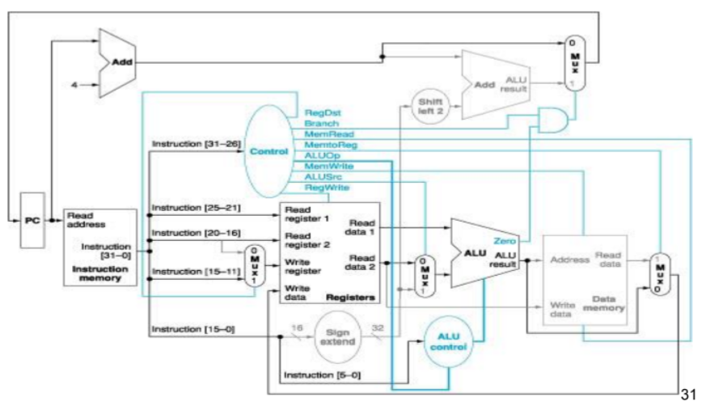

**The project consists of:-**

1- Mux 5 bits

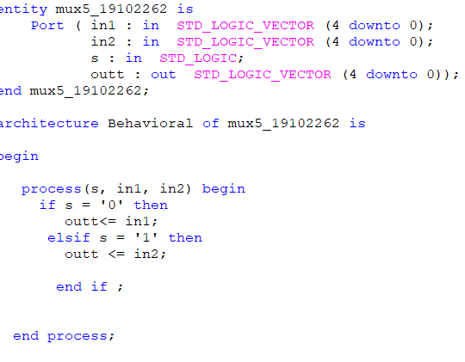

2- Registers file

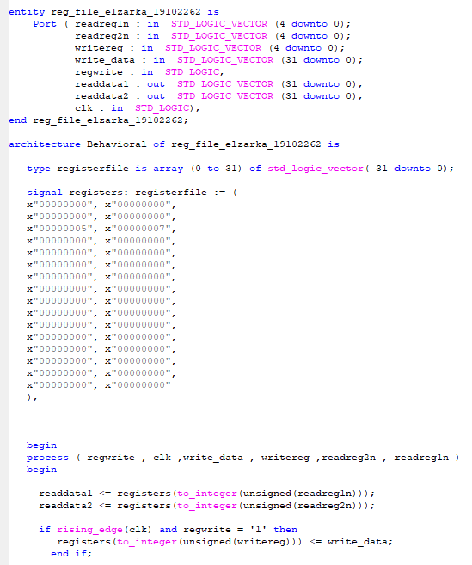

3- Sign extend

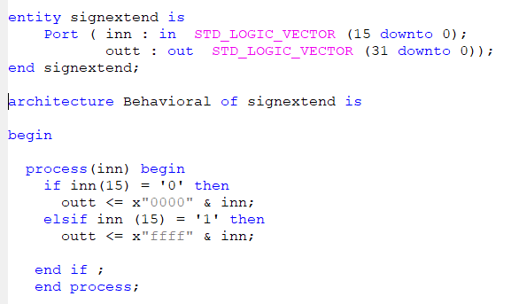

4- ALU control

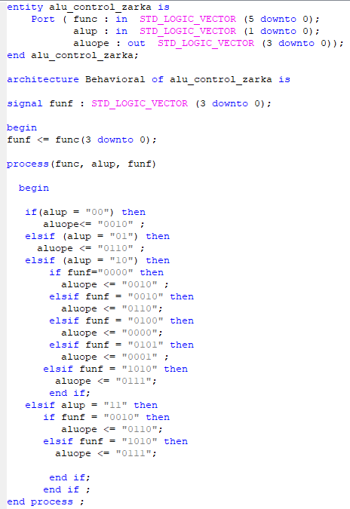

5- PC

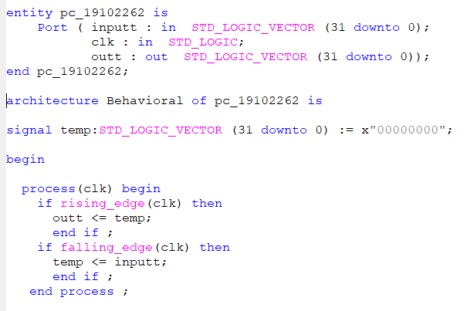

6- adder to number (4)

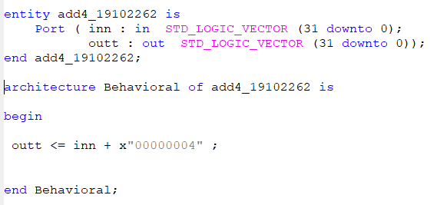

7- Instruction memory

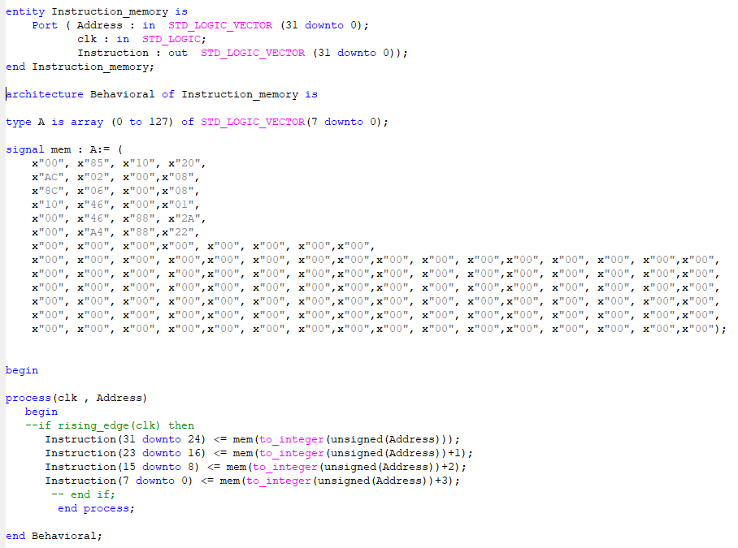

8- ALU

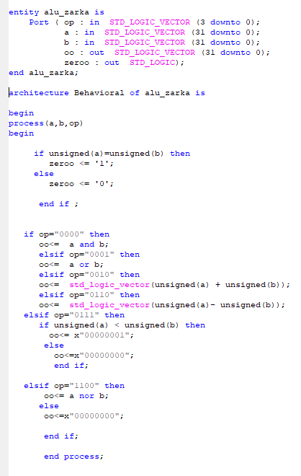

9- adder

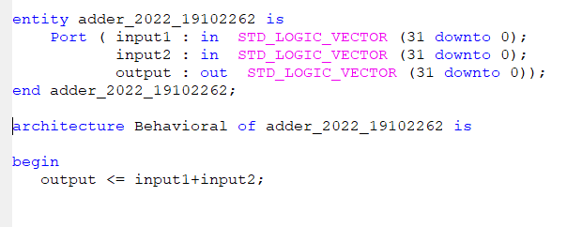

10- shift left

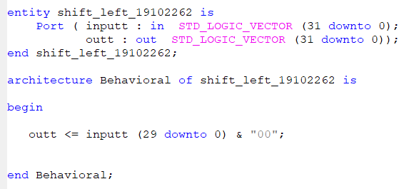

11- 3 mux 32 bit

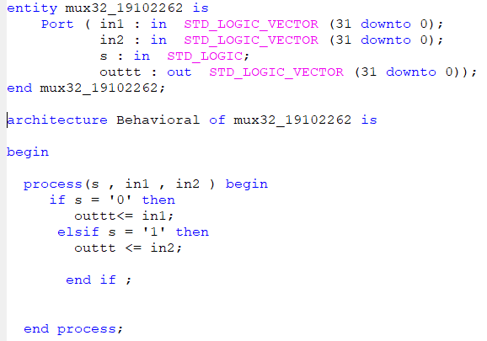

12- Data memory

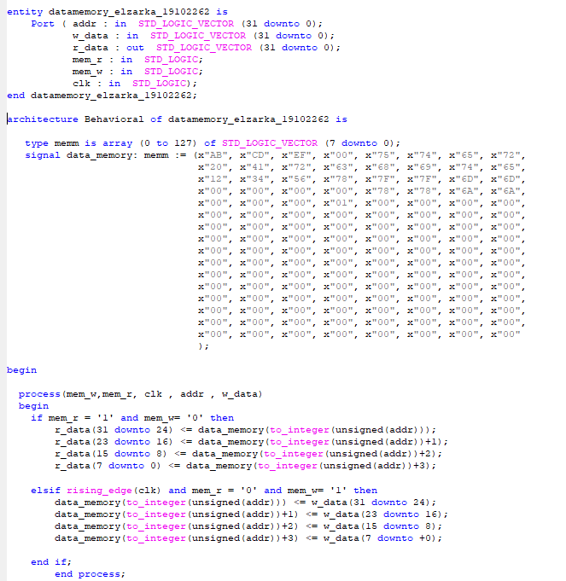

13- Control Unit

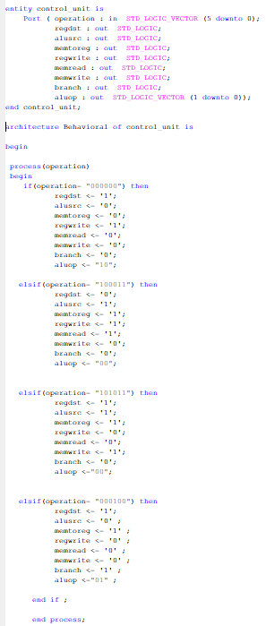

**The tested simulation:-**

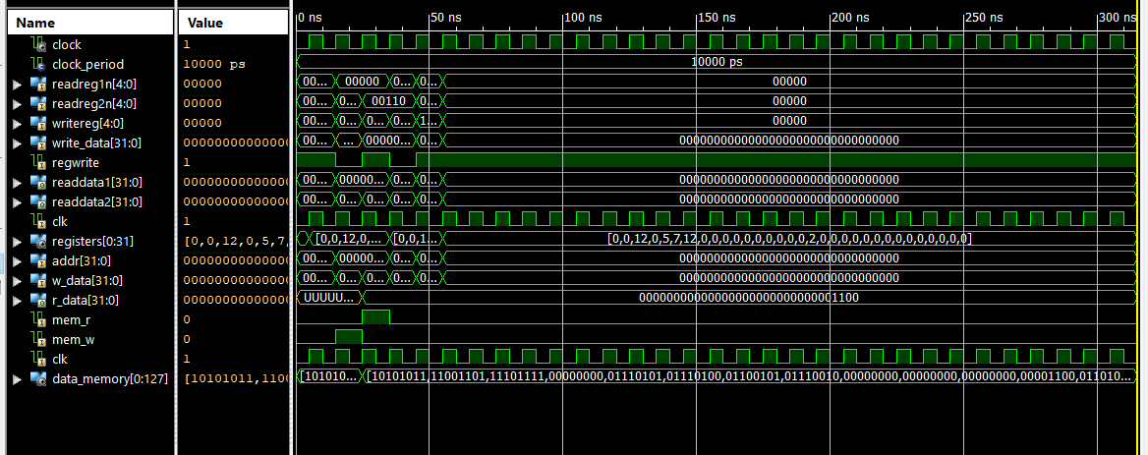

1. First clock : add $v0, $a0, $a1

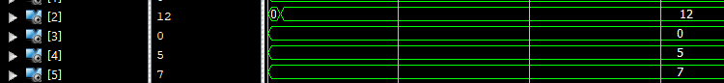

1. 2’s clock : sw $v0, 8($zero)

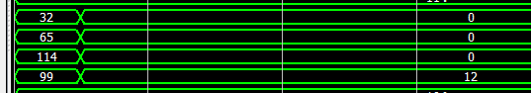

1. 3’s clock : lw $a2, 8($zero)



1. 4’s clock: beq $v0, $a2, Good_Processor

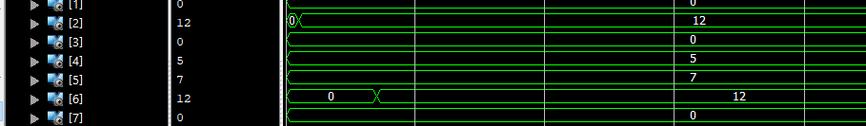

1. 6’s clock : Good_Processor: sub $s1, $a1, $a0

*note 5’s clock with (SLT) will not be executed because V0 = a2 .